How to Execute Code?

1. Follow the steps
2. To execute the code please install the python on you PC
3. Then open the terminal and redirect to the current code folder
4. Installing requirements (Take some time and require internet connection)
   1. Run the command pip install -r Requirement.txt
5. Making Serve Run
   1. Go to the API folder
   2. Open CMD
   3. Run the command uvicorn Text_Extraction_Server:app –-reload
   4. Now the URL shown on the screen on browser 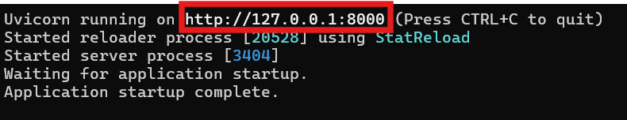
   5. If you see below kind of image then your serve is ready is not then troubleshoot it

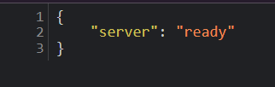

1. Now go to the frontend folder and run the frontend.html
2. Now you are ready to go
3. If Want to test the code the one pdf and doc file is given in the Test Files folder you can refer that for testing

Thank You